**Assignment No- 15**

**Create a serverless computing service.**

1. Search lambda, create function, give function name. Select on Enable function url in additional configurations.

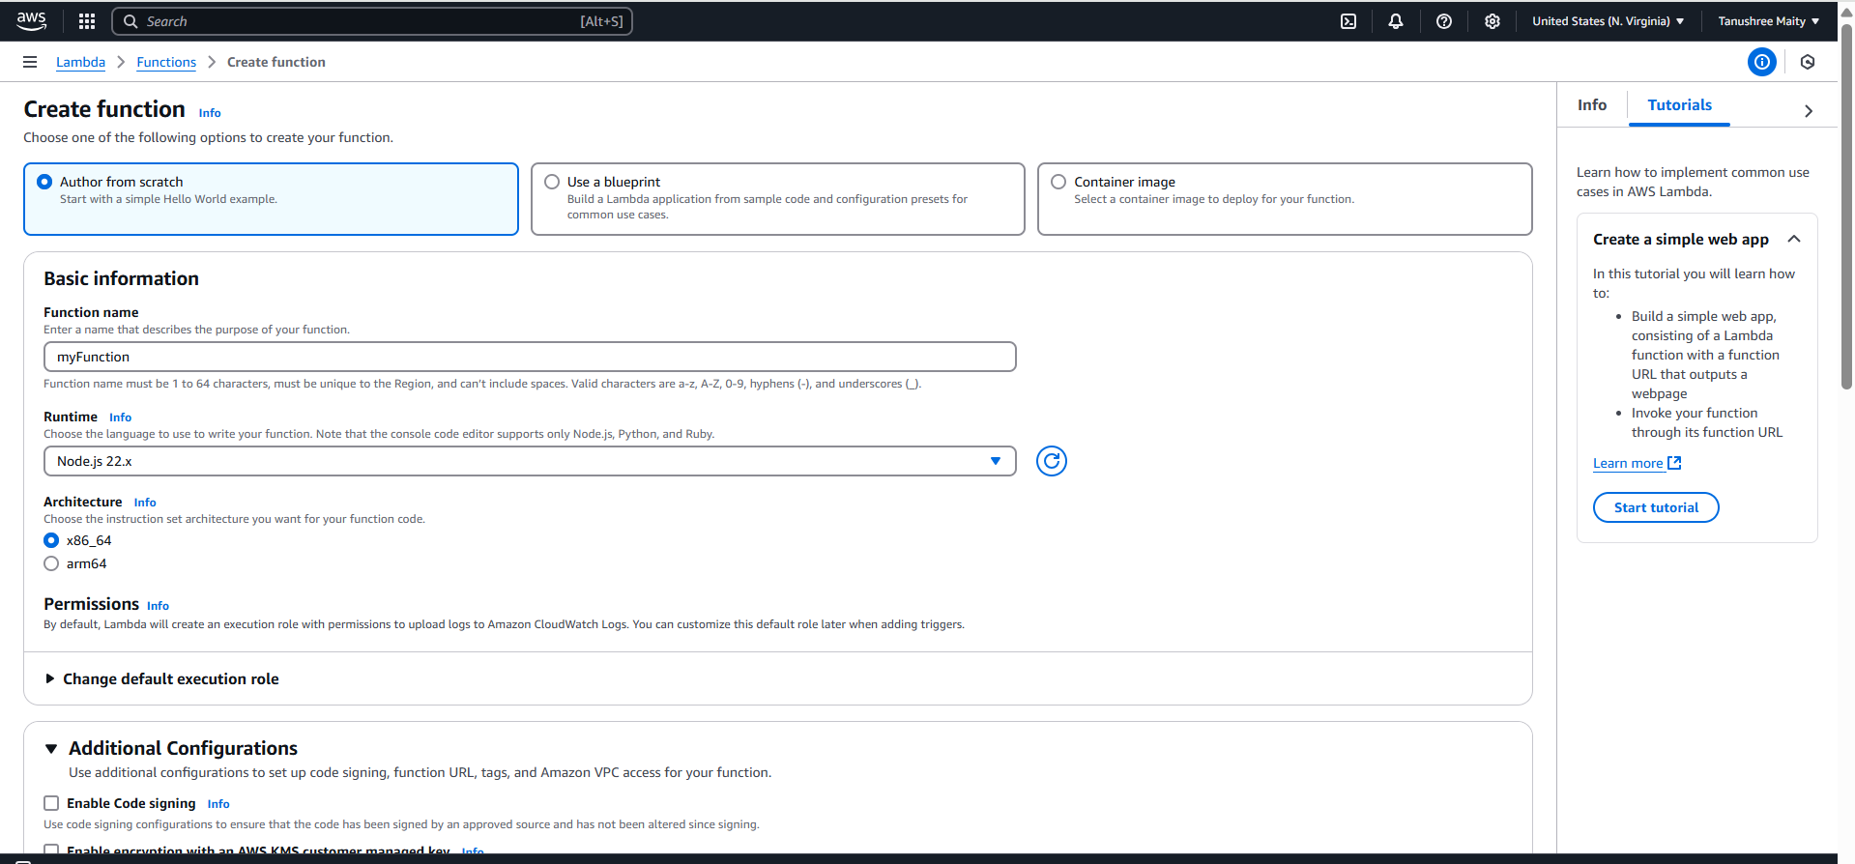

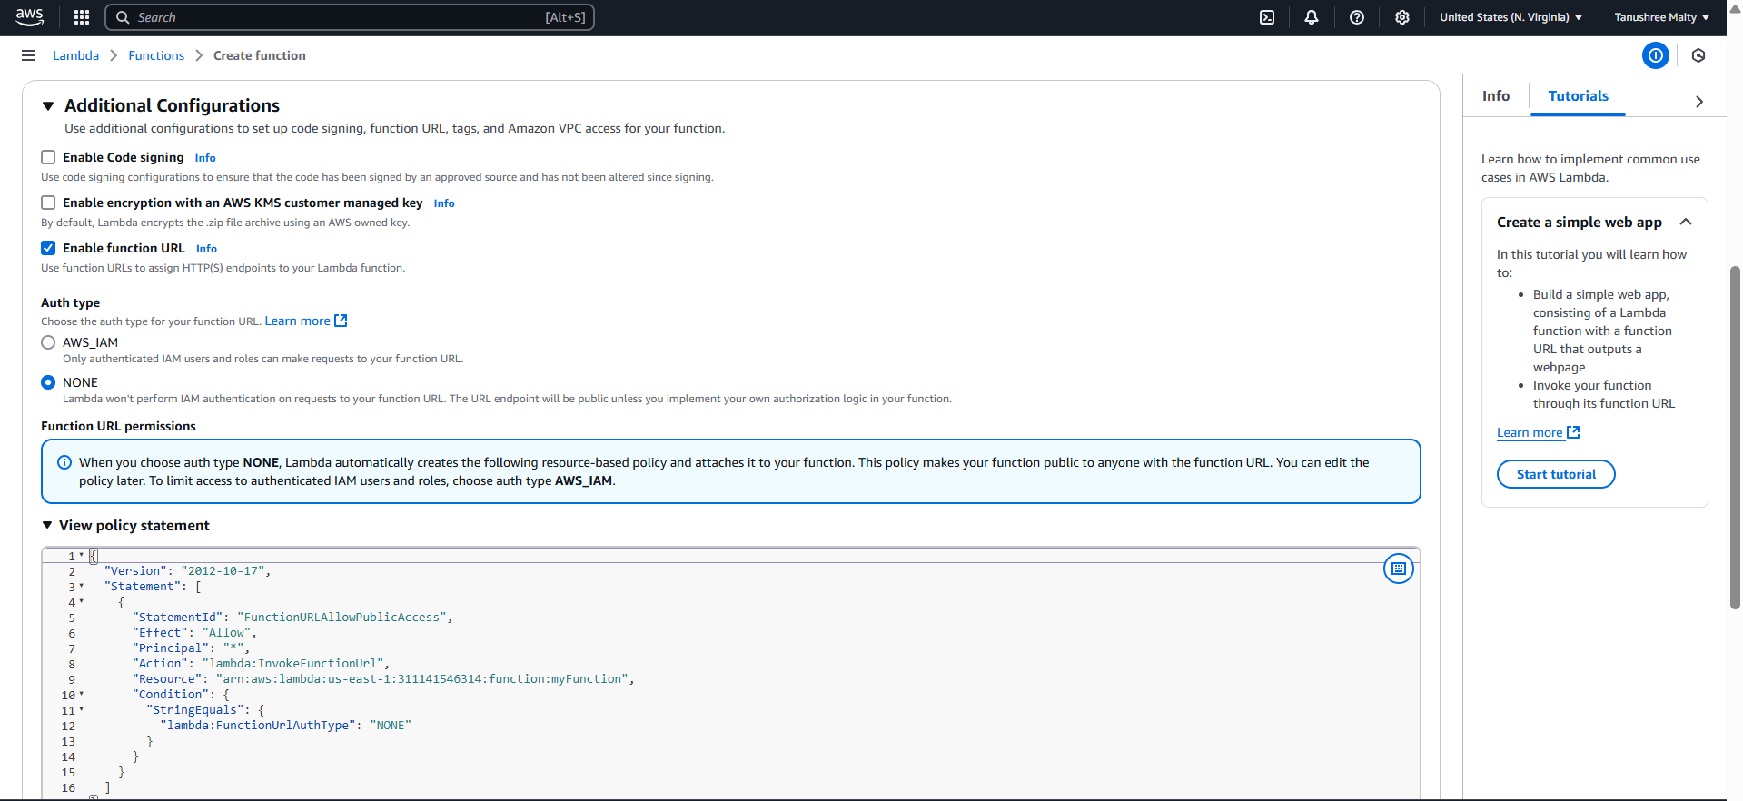

1. Copy Function URL and paste it on new tab.

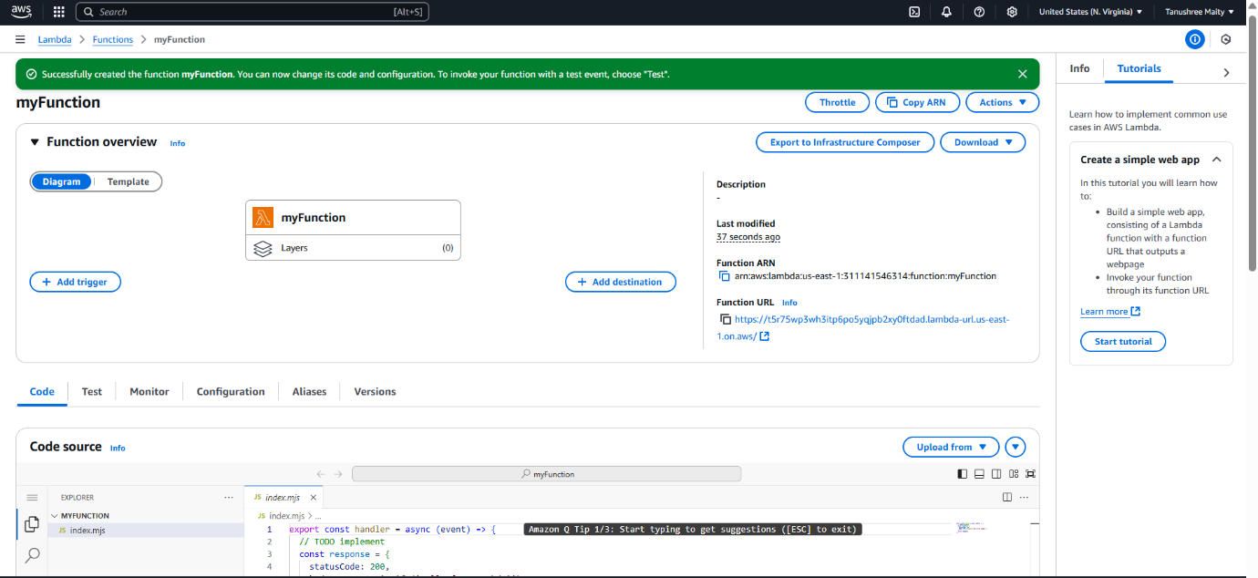

1. Output is.

